Customer Segmentation Report

Overview
This report presents a Customer Segmentation Analysis using the RFM (Recency, Frequency, Monetary) model. The objective of the analysis was to identify different customer groups based on purchasing behaviour and provide actionable business recommendations for improving customer retention, engagement, and profitability.

The dataset was analysed using the following RFM metrics:
- Recency – Number of days since the customer’s last purchase
- Frequency – Total number of purchases made by the customer
- Monetary – Total revenue generated by the customer

Each customer was assigned RFM scores ranging from 1 to 5, where higher scores represent stronger customer engagement and value.

RFM Analysis Process

1. Recency Calculation
Recency was calculated by finding the difference between the latest transaction date in the dataset and each customer’s most recent purchase date.

2. Frequency Calculation
Frequency was calculated by counting the total number of transactions made by each customer.

3. Monetary Calculation
Monetary value was calculated by summing the total sales generated by each customer.

4. RFM Scoring
Customers were assigned scores from 1 to 5 for each RFM metric using quantile-based ranking. Higher scores indicate:
- More recent purchases
- Higher purchase frequency
- Higher spending behaviour

5. Customer Segmentation
Customers were categorized into different business segments based on their RFM scores.
Customer Segments and Business Impact

1. High-Value Customers
These customers have high recency, frequency, and monetary scores. They purchase frequently, spend the most, and remain actively engaged with the business.

Business Impact:
- Major contributors to overall revenue and profitability
- Strong brand loyalty
- High customer lifetime value

Recommended Strategy:
- Offer premium rewards and loyalty programs
- Provide early access to products and exclusive offers
- Focus on retention and personalized communication

2. Loyal Customers
These customers purchase frequently and engage consistently but may spend slightly less than high-value customers.

Business Impact:
- Stable and recurring revenue source
- Strong long-term customer relationships

Recommended Strategy:
- Introduce loyalty points and membership benefits
- Encourage upselling and cross-selling
- Maintain consistent engagement through email campaigns

3. Potential Loyalists
These customers have recently engaged with the business and show strong spending potential but lower purchase frequency.

Business Impact:
- High potential for conversion into loyal customers
- Opportunity for long-term customer retention

Recommended Strategy:
- Offer personalized product recommendations
- Provide limited-time offers and engagement campaigns
- Encourage repeat purchases through targeted discounts

4. New Customers
These customers recently made purchases but have low purchase frequency and lower spending levels.

Business Impact:
- Important for future business growth
- Require nurturing and onboarding

Recommended Strategy:
- Create welcome campaigns and onboarding emails
- Offer first-time purchase incentives
- Encourage repeat engagement through targeted promotions

5. At-Risk Customers
These customers previously purchased frequently or spent significant amounts but have not purchased recently.

Business Impact:
- Risk of customer churn
- Potential loss of valuable customers

Recommended Strategy:
- Launch re-engagement campaigns
- Offer personalized discounts or reminders
- Identify reasons for inactivity and improve retention strategies

6. Lost Customers
These customers have low recency, low frequency, and low monetary scores.

Business Impact:
- Minimal current contribution to revenue
- Low engagement with the business

Recommended Strategy:
- Use low-cost remarketing campaigns
- Send win-back offers or surveys
- Focus business resources primarily on higher-value segments

7. Dormant High-Value Customers
These customers previously generated high revenue but are no longer actively engaged.

Business Impact:
- Significant opportunity for revenue recovery
- Previously valuable customers with strong purchase history

Recommended Strategy:
- Provide exclusive reactivation offers
- Use personalized retention campaigns
- Prioritize for targeted win-back marketing

Key Insights
- High-Value customers generated the highest average monetary value and profitability.
- Loyal customers showed strong purchase frequency and consistent engagement.
- At-Risk and Dormant High-Value customers represent important retention opportunities.
- Lost customers formed a significant portion of the customer base, indicating potential customer churn issues.
- Potential Loyalists and New customers provide future growth opportunities if properly nurtured.

Visualizations Included
The following visualizations were created to support the analysis:

1. Bar Chart – Customer Count by Segment
Shows the distribution of customers across different RFM segments.
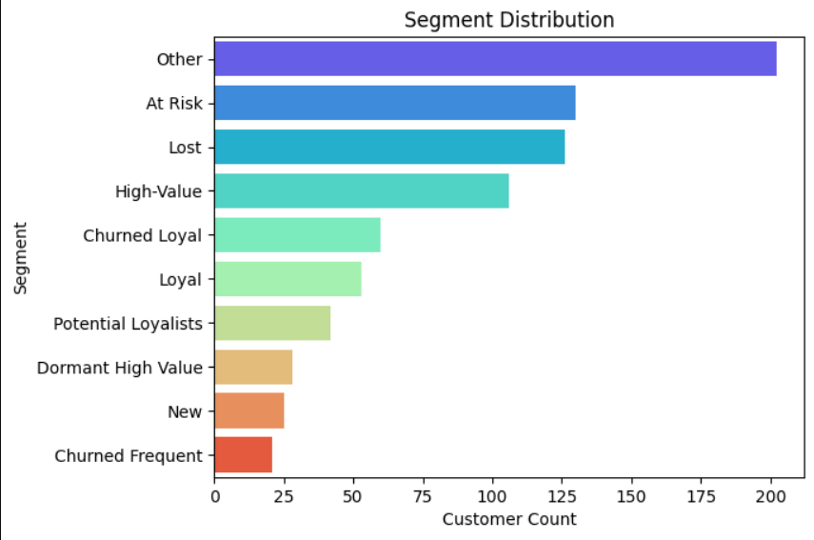
2. Pie Chart – Segment Distribution
Shows the proportion of each customer segment within the overall customer base.
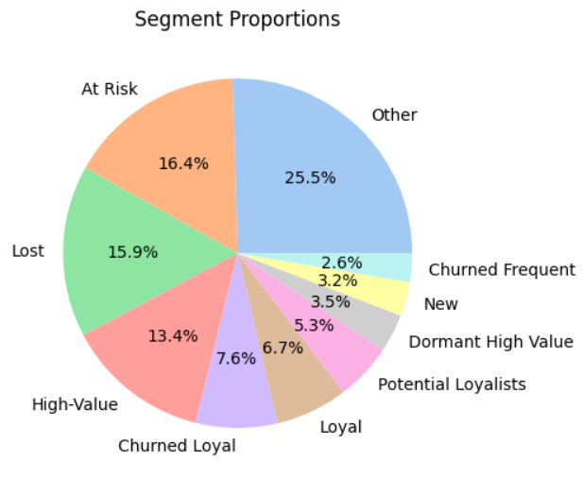
3. Heatmap – Average RFM Scores by Segment
Highlights behavioural differences across customer segments.
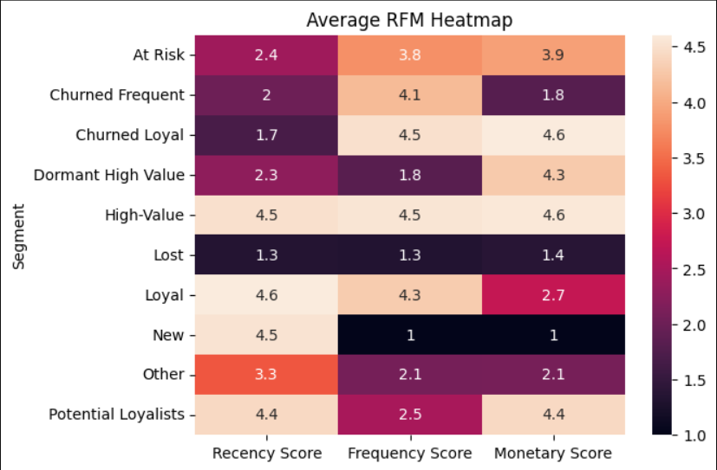

4. Bubble Chart – RFM Customer Distribution
Visualizes the relationship between Recency, Frequency, and Monetary metrics using bubble size and customer segments.
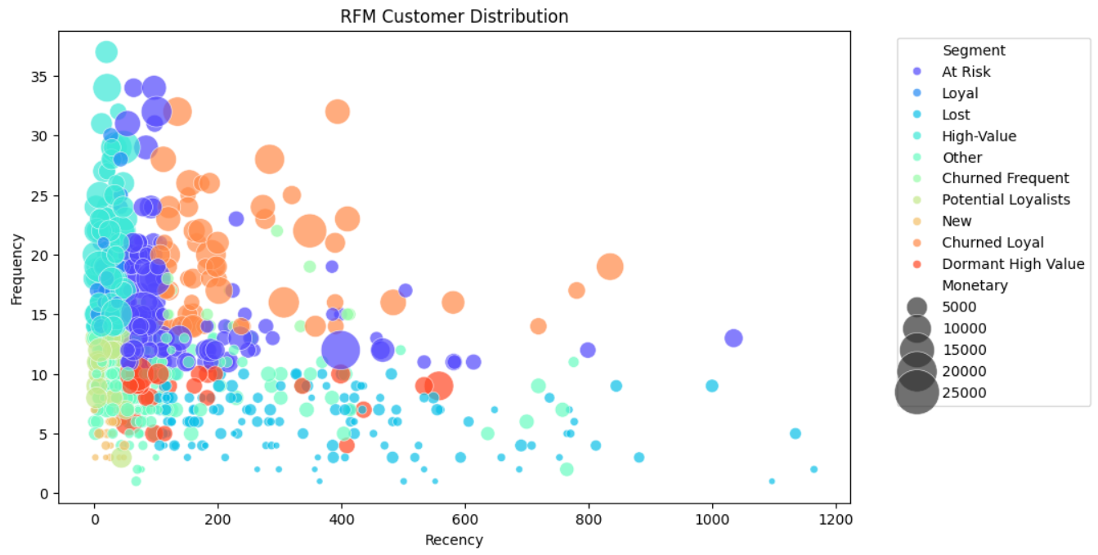

Conclusion
The RFM analysis successfully identified key customer groups based on purchasing behaviour and customer value. The segmentation provides valuable insights for targeted marketing, retention strategies, and customer relationship management.

Businesses can use these insights to:
- Retain high-value customers
- Re-engage inactive customers
- Improve customer loyalty
- Increase long-term profitability
- Personalize marketing campaigns
The final segmented dataset can also support future predictive analytics and customer behaviour analysis.

